

|  |
| --- |
| Best Buy  Design Document |
|  |
| September 27  Authored by: Jaelle Amongi  Kafeero David  Antony Nabende |



1. Introduction

This document is the design report for a web-based Shopping Mall. This is mainly about ‘how to do’ and also will help provide an insight to the whole system design and implementation of the online

Shopping Mall.

This software has the following three main components:

1. Implement the different types of user – Administrator and Customers.

2. Implement shopping cart for checkout and payment procedures.

3. Management of products and orders.

* 1. Purpose

The purpose of this project is to create a functional website for people to be able to buy goods. Users of this website will be able to create an account .The basic requirements state that the users will be able to securely register and manage their profiles. They will also be able to navigate through available items by category, or by using a well-executed search function.

The website will be maintained and managed by administrators. The administrator will also be able to control customers and visitors actions.

1.2 Project Scope

For this project we want to define what will be done such that the final product meets expectations. With this in mind, the following are the parts that will be completed:

• Secure registration and profile management facilities for customers

• Browsing through the e-Mall to see the items that are there in each category of products like Apparel, Kitchen Accessories, Bath Accessories, Food, etc.

• Adequate searching mechanisms for easy and quick access to particular products and services.

• Payment mechanism and gateway for mobile money and other relevant payment options.

1.3 Technologies to be used

In order to credit the tools we will use and to provide some insight as to what is needed to create a project like this, the list below will highlight all software and technologies used in order to create the project and what it was used for.

HTML - Used to structure and layout the web pages.

CSS – For the page styling and design.

MySQL - Database management system

JavaScript and jQuery – Page functionality and responsiveness.

2. Product Functions

2.1 For Users

•Basic Account features are required for both Customers and Sellers.

This includes

•Registering

•Login

•Forgot/change passwords

•“Account Details” section containing contact details

•Browse and Search: User should be able to browse through the entire items list by modifying certain selection criteria's such as: Item category, Price range selection, and Item/Seller Rating based selection.

In addition to providing the above mentioned search feature, user should also be able to search for a particular product.

•Shopping: Customer should have the option to buy desired item(s) sold.

•Customer will have access to finalize product lists of items she wishes to buy and make the final payment

•Shopping history: List of items previously shopped.

•Item View history: List of recently viewed items

2.2 For Administrators

•Account Setting up.

•Updating product information

•Monitoring transactions and keeping track of its status.

•Update Customer transaction information (In case of system errors/complaints).

2.3 User Classes and Characteristics

The system will be implemented for following users:

•For Customers/Visitors

A customer will be able to purchase items through the shopping mall. She will also be able to see her purchase history. A secure session would be maintained and a user name and password would be allocated for every customer. Customers won’t be able to make changes to the system. She will only be able to browse through the items using search function and checkout them. She can then purchase it online via the secure payment method and by providing her billing address and shipping address. Customers will also be able to provide reviews for various items and rate them.

•For Administrators

An administrator has more privileges than regular user. Main functions of an administrator will be the management of customers. Administrators can view, modify and delete the personal information and passwords of members if necessary. They would also be able to search information about members and vendors.

Administrators will also be able to view the invoice list of placed orders, orders that have shipped, and disqualified orders.

1. Control Flow of Users

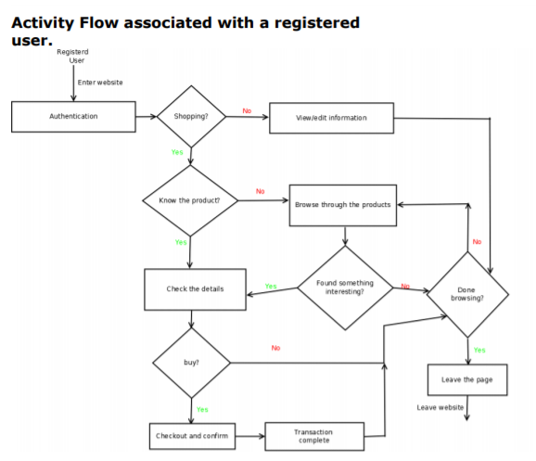

# 

|  |
| --- |
| 4.Conclusion  The application is an E-commerce application that is easy to use, since it uses the GUI provided in the user dialog. User friendly screens are provided. The application is easy to use and interactive making online shopping a recreational activity for users.  The ‘Online Shopping’ is designed to provide a web based application that would make searching, viewing and selection of a product easier.  The search engine provides an easy and convenient way to search for products where a user can search for a product interactively and the search engine would refine the products available based on the user’s input. The user can then view the complete specification of each product. They can also view the product reviews and also write their own reviews. |
| Prepared by:  Antony Nabende  Kafeero David  Jaelle Amongi |
| 4.Conclusion  The application is an E-commerce application that is easy to use, since it uses the GUI provided in the user dialog. User friendly screens are provided. The application is easy to use and interactive making online shopping a recreational activity for users.  The ‘Online Shopping’ is designed to provide a web based application that would make searching, viewing and selection of a product easier.  The search engine provides an easy and convenient way to search for products where a user can search for a product interactively and the search engine would refine the products available based on the user’s input. The user can then view the complete specification of each product. They can also view the product reviews and also write their own reviews. |